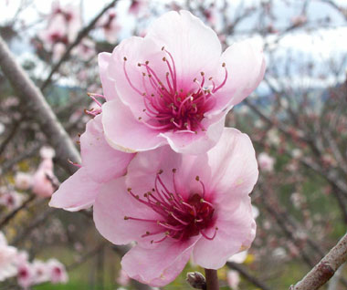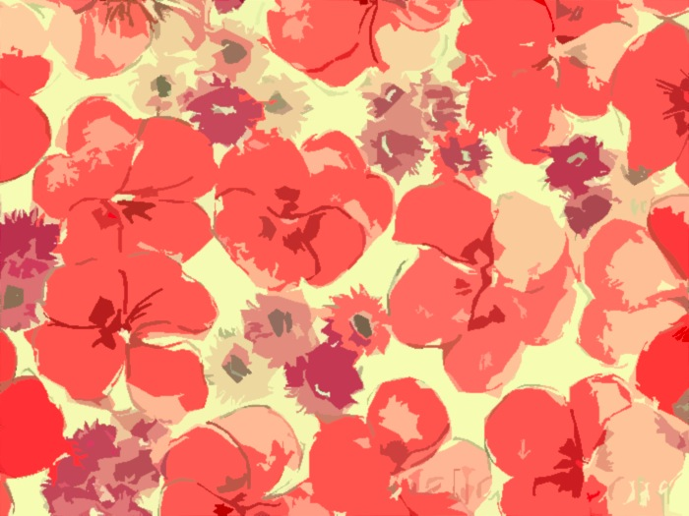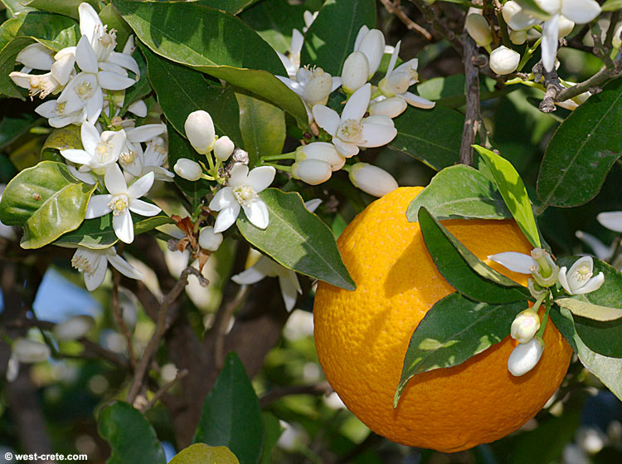**Darling Cosmetics**

**Heather Macomber, Rilee Scalan, Alex Smith Smith**

Ethanol

Sweet Orange

Violet

Rose Garden

Phenonip

Contains fragrances which may irritate skin, including rose, orange, and violet

Ingredients list

**Warnings**

To make perfume, we had to mix ethanol with our desired scents. First, we chose a specific amount of ethanol. We used about 2/3 in our perfume . We then mixed 45 drops of different scents into the ethanol. Using an eyedropper, we added Rose Garden, Sweet Orange, Bramble Berry, and Violet into the ethanol and created a floral, fruity, youthful scent

How it’s Made

*Description Chemistry*

*Most women and many men worldwide use a perfume or cologne to smell appealing and refreshed. It’s so common that rarely does anyone think about the chemistry behind how these smells reach our nostrils. But before we can talk about how perfume works, first we need to understand how humans smell. Humans are capable of detecting over 10,000 smells by using 400 receptors within our noses. The molecules of scent carried through the air fit like a puzzle piece into certain receptors, triggering a response in the nervous system that translates this knowledge to the brain. To create an essential oil for use in a perfume from a plant, the essence of the smell must be distilled through use of heat and pressure. Synthetic smells are also often made in a lab. These scents are usually light with a small molecular weight and volatile. To spread the scent of a perfume away from your body so it can propagate throughout the room, the essential oils in the perfume are dissolved in a solvent, most commonly ethanol alcohol. In a perfume, the actual scents themselves rarely make up more than one-third of the mixture. So why alcohol? Alcohol forms half as many hydrogen bonds as water, because ethanol only has one hydrogen. This means the intermolecular forces within ethanol are less strong, so it evaporates quickly into the air, carrying the scent with it according to Graham’s laws of diffusion.*

*Description Chemistry*

*How such a simple household item, soap, functions on a molecular level is much more complex than most would imagine. It all begins with fatty acids. A fatty acid is a string of carbons with hydrogen’s attached, and at least one oxygen with a hydrogen at the end. A saturated fatty acid has no double bonds, while an unsaturated fatty acid has at least one double bond in the carbon chain. When three fatty acids link with a glycerol molecule it is called a triglyceride. To create soap, this triglyceride needs to combine with a strong base to produce a carboxylate salt and glycerol. What is a strong base? “Base” is a term that applies to the Ph of a material, if it is over 7 it is considered basic. A strong base has a Ph of 11 or 12. The base used to produce our soap was Sodium Hydroxide, known commonly as lye. During the process of saponification, the sodium detaches from the lye and swaps places with the oxygen group from the triglyceride. This double displacement reaction forms the carboxylate salt, which is what gives soap its cleaning power, and glycerin, a moisturizing by-product of the reaction. Now that we know how soap is made, how does it actually clean your body and clothing? It all has to do with electronegativity. A molecule of soap has a very non-polar end and a polar end. This split personality allows soap to be the bridge between the nonpolar molecules of oil on your skin and polar H2O. Because of the split nature of soap, it breaks the surface tension of water, allowing it to get into every nook and cranny of dirt.*

To first make soap, we had to make lye. Then we measured out our fats and fragrances, and melted our fats together. We then waited for it cool to 35 degrees C. Then we added the lye and started the saponification process!. When it reached a pudding-like consistency and started to trace, we added our colors and scents. We then put it in our molds and let it set. To finish we had to test the PH to make sure it was safe to use. Our PH was below 10 and our soap was ready to use!

How it’s Made

Perfume in Innocence

$2 for .5oz and $4 for 1oz

This light, floral-fruity scent is perfect for the summertime, leaving you feeling refreshed, rejuvenated, and happy

Sodium Laurate

Sodium Oleate

Sodium Palmitate

Sodium Myristate

Sodium Linoleate

Sodium Caprate

Sodium Stearate

Glycerin

Water

Peach Blossom

Sweet Orange

Juniper Breeze

Mango Madness

Orange Peach Colorant

Ingredients list

**Warnings**

Contains fragrances which may irritate skin, including coconut, mango, orange and juniper

Moisturizing Soap in Elegance

$5

This luxurious soap has a rich, creamy lather that leaves skin soft and smooth with just a hint of youthful fragrance

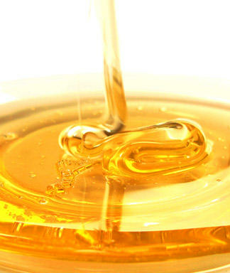**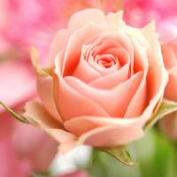Darling Cosmetics**

**Heather Macomber, Rilee Scalan, Alex Smith Smith**

**Citations**: http://en.wikipedia.org/wiki/Emulsion, http://en.wikipedia.org/wiki/Sugar, http://en.wikipedia.org/wiki/Petroleum_jelly, http://www.personalcaremagazine.com/Print.aspx?Story=3074, http://www.statesymbolsusa.org/Delaware/flower_peachblossom.html, http://www.west-crete.com/dailypics/photos/905large.jpg, http://www.bridgat.com/honey_products-b817_0.html, http://flowerpicturegallery.com/v/flowers-rose-pictures/pinkish+peach+rose.jpg.html

We started by testing the color and flavor we wanted our lipgloss to be. We took test tubes of water and mixed in various amounts and variants of raspberry, pink lemonade, and peach tea. We decided we wanted to use a mix of pink lemonade and peach tea to make our lipgloss. To make the base we mixed together vaseline, honey, and the flavored packets mentioned above. We heated it up in a microwave, and forced the emulsion with a hand blender, then let cool.

We gathered our ingredients and measured out equal parts sugar and oils. We poured the sugar into a bowl, and slowly mixed the oils into it, beginning with olive and then transitioning to grapeseed. We then added our Vitamin E and Jojoba oil, stirring well. After the sugar had reached a stable consistency, we added our fragrances and colorant, and continued to stir. After testing to ensure proper functionality, we had created sugar scrub!

How it’s Made

*Description Chemistry*

*Sugar scrubs have been used as an exfoliating agent for centuries, and for good reason. It is a wonderful way to quickly soften your skin and provide moisture. Exfoliation can be achieved through two main processes, mechanical and chemical. Our scrub uses a mainly mechanical method, abrasion. This is possible because of the chemical structure of granulated sugar, known chemically as sucrose. Sucrose is a disaccharide molecule comprised of 12 atoms of carbon, 11 atoms of oxygen, and 22 atoms of hydrogen. It possesses a bonded glucose ring and fructose ring. Because of this structure, sugar naturally crystalizes into oblong rectangular shapes with sharp edges. It is these abrasive sides that scrub off the top layer of dead skin cells, leaving only the fresh, new cells behind. After this exfoliation, the rejuvenating oils in our scrub kick in. The highly concentrated fatty acids in Grapeseed and jojoba oil are occlusive moisturizers, which form a protective coat on your skin and soak in to provide moisture.*

*Description Chemistry*

*Lip gloss is one of the easiest ways to freshen your look. But how does lip gloss give its signature shine at a chemical level? The recipe of lip gloss that we used is made of mostly Vaseline, honey, and water. Vaseline, known commonly as petroleum jelly, is a nonpolar hydrocarbon. It’s low electronegativity means that it is hydrophobic, and not soluble in water. H20 has an unequal sharing of electrons between the oxygen and the hydrogen’s, making it a polar dipole. To mix these two substances, we needed an emulsifier to create an emulsion. An emulsion is simply a mixture of two substances that don’t normally mix, and honey is a natural emulsifier that helps bridge the gap between water and the oils found in Vaseline. Glucose, the main ingredient in honey, forms a protective coat around tiny beads of oil, preventing it from clumping at the surface of the mixture. To create the flavor bursts of fruit in our lip-gloss, we needed to find a way to protect the powder from dissolving in water. To do this, we mixed it with the Vaseline and not the water. The main ingredients in crystal light are aspartame, an artificial sweetener, and citric acid. Because both of these ingredients are polar, they do not dissolve in oil such as Vaseline, and stay in “pockets” of flavor. When the Vaseline is emulsified with water, the pockets of oil-coated sugars stay insoluble.*

How it’s Made

Ingredients list

**Warnings**

Contains ingredients which may irritate skin, including rose, peach blossom, grape, and olive

Vitamin E

Peach Blossom

Rose Garden

Orange Peach Colorant

Sucrose

Olive Oil

Grapeseed Oil

Water

Jojoba Oil

Citric Acid

Aspartame

Ascorbic acid

Vitamin C

Vitamin E

Potassium Bicarbonate

Malic Acid

Petrolatum

Water

Fructose

Sucrose

Glycerin

Cetearyl Alcohol

Microcrystalline Wax

Contains honey and asparteme

**Warnings**

Ingredients list

Lip Gloss in Brilliance

$2

This delicious lip gloss contains flavor bursts of mango and pink lemonade, with antioxidant-rich green tea extract and vitamin E, it leaves a subtlety brilliant shine and healthy lips

Sugar Scrub in Radiance

$5

This exfoliating scrub has a light floral scent and is formulated with moisturizing jojoba oil and vitamin e for radiant skin

Sodium Laurate

Sodium Oleate

Sodium Palmitate

Sodium Myristate

Sodium Linoleate

Sodium Caprate

Sodium Stearate

Sodium Alpha Linoneate